// Stack

#include <stdio.h>
#include <stdlib.h>

struct node {
int data;
struct node* link;
}*top = NULL;

int isEmpty() {
if(top == NULL)
return 1;

else
return 0;
}

int peek() {
if(isEmpty()){
printf("\nStack Underflow!\n");
return 0;
}

else {
printf( "\nThe peeked element is: %d\n", top->data);
}
}

int pop() {
int item = top -> data;
struct node *tmp;
if(isEmpty()){
printf("\nStack Underflow!\n");
return 0;
}

else {
tmp = top;
top = top -> link;
free(tmp);
return item;
}
}

int push(int info) {
struct node* tmp;
tmp = (struct node*) malloc (sizeof(struct node*));
if(tmp == NULL){
printf("\nInsufficient Memory!\n");
return 0;
}

tmp -> link = top;
tmp -> data = info;

top = tmp;
return 0;
}

void display() {
struct node* p;
p = top;
if(isEmpty()){
printf("\nStack Underflow!\n");
}
else {
while (p != NULL){
printf("\n%d", p -> data);
p = p -> link;
}
}
}

int main() {
int opt;
int data;

while (1)
{
printf( "\n\t-- Options --\n1. Push Element into Stack.\n2. Pop Element from Stack.\n3. Display Elements from Stack.\n4. Peek\n5. Exit\n\tChoose: ");
scanf( "%d", &opt );

switch ( opt )
{
case 1:
printf( "\nEnter an integer: " );
scanf("%d", &data);
push(data);
break;

case 2:
pop();
break;

case 3:
display();
break;

case 4:
peek();
break;

case 5:
printf( "\nThanks for using the program!\n" );
exit(1);
break;

default:
printf( "\nPlease choose a valid option\n" );
break;
}
}
}
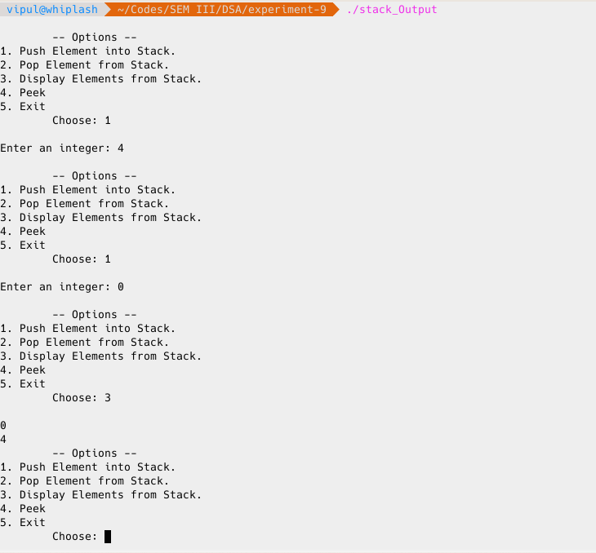
// Queue

#include <stdio.h>
#include <stdlib.h>

struct node {
int data;
struct node* link;
}*front = NULL, *rear = NULL;

int isEmpty() {
if(front == NULL && rear == NULL)
return 1;

else
return 0;
}

int pop() {
struct node *tmp;
int info;
if(isEmpty()){
printf("\nStack Underflow!\n");
return 0;
}

else if(front == rear){
rear = NULL;
}

info = front -> data;
tmp = front;
front = front -> link;
free(tmp);
return info;
}

int push(int info) {
struct node* tmp;
tmp = (struct node*) malloc (sizeof(struct node*));
if(tmp == NULL){
printf("\nInsufficient Memory!\n");
return 0;
}

else{
tmp -> link = NULL;
tmp ->data = info;

if(front == NULL)
front = tmp;

else
rear -> link = tmp;

rear = tmp;
}
}

void display() {
struct node* p;
p = front;
if(isEmpty()){
printf("\nStack Underflow!\n");
}
else {
while (p != NULL){
printf("\n%d", p -> data);
p = p -> link;
}
}
}

int main() {
int opt;
int data;

while (1)
{
printf( "\n\t-- Options --\n1. Push Element into Queue.\n2. Pop Element from Queue.\n3. Display Elements from Queue.\n4. Exit\n\tChoose: ");
scanf( "%d", &opt );

switch ( opt )
{
case 1:
printf( "\nEnter an integer: " );
scanf("%d", &data);
push(data);
break;

case 2:
pop();
break;

case 3:
display();
break;

case 4:
printf( "\nThanks for using the program!\n" );
exit(1);
break;

default:
printf( "\nPlease choose a valid option\n" );
break;
}
}
}

